Cheat sheet 1: Basics of EIT – Static case

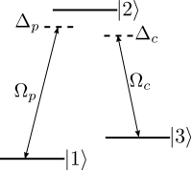

$$H=\frac{ℏ}{2}\left(\begin{matrix}0 & Ω_{p} & 0 \\ Ω_{p} & -2Δ_{p} & Ω_{c} \\ 0 & Ω_{c} & -2(Δ_{p}-Δ_{c})\end{matrix}\right)$$

# Eigenstates and –energies

$|a_{0}〉=\cos{θ}|1〉-\sin{θ}|3〉$

$|a_{+}〉=\sin{θ}\sin{ϕ}|1〉+\cos{ϕ}|2〉+\cos{θ}\sin{ϕ}|3〉$

$|a_{-}〉=\sin{θ}\cos{ϕ}|1〉-\sin{ϕ}|2〉+\cos{θ}\cos{ϕ}|3〉$

$ℏω_{0}=0$

$ℏω_{±}=\frac{ℏ}{2}\left(Δ_{p}±\sqrt{Δ_{p}^{2}+Ω_{p}^{2}+Ω_{c}^{2}}\right)$

$\tan{θ=\frac{Ω_{p}}{Ω_{c}}} \tan{2ϕ=\frac{\sqrt{Ω_{c}^{2}+Ω_{p}^{2} }}{Δ_{p}}}$

**Parameters for EIT regime**: $Δ_{p}=0, Δ_{p}-Δ_{c}=0, Ω_{p}≪Ω_{c}⇒|a_{0}〉≃|1〉.$

# Optical response for weak probe field

1. Master equation: $\frac{dρ}{dt}=\frac{1}{iℏ}\left[H,ρ\right]+Lρ$  
    ($L$: Lindblad superoperator for decay/dephasing)
2. Consider perturbative regime: $Ω_{p}$ small $⇒\frac{dρ_{11}}{dt}≃0$ and $ρ_{11}≃1$.

Induced atomic polarization: $P_{12}=\frac{N}{V}μ_{12}ρ_{12}=ϵ_{0}χ\left(ω_{p}\right)$ where $γ_{j}$: decoherence rate of $|j〉$, $δ=Δ_{p}-Δ_{c}$

$$⇒χ\left(ω_{p}\right)=\frac{N}{V}\frac{{\left|μ_{12}\right|}^{2}}{ϵ_{0}ℏ}\left\{\frac{4δ\left({\left|Ω_{c}\right|}^{2}-4δΔ\right)-4Δ_{p}γ_{3}^{2}}{{\left|{\left|Ω_{c}\right|}^{2}+\left(γ_{2}+2iΔ\right)\left(γ_{3}+2iδ\right)\right|}^{2}}+i\frac{8δ^{2}γ_{2}+2γ_{3}\left({\left|Ω_{c}\right|}^{2}+γ_{2}γ_{3}\right)}{{\left|{\left|Ω_{c}\right|}^{2}+\left(γ_{2}+2iΔ\right)\left(γ_{3}+2iδ\right)\right|}^{2}}\right\}$$

Remember: $Im χ→$ absorption, $Re χ→$ refractive index

# Example plots for $Δ_{c}=γ_{3}=0$

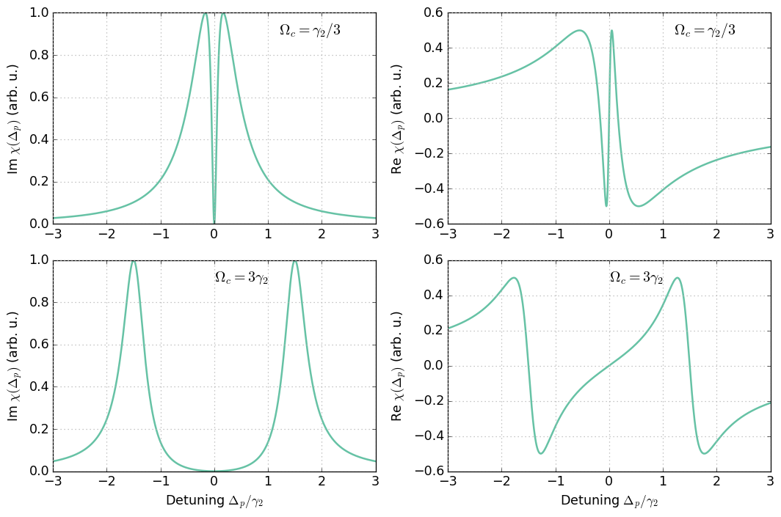

# Further reading (optional)

1. Fleischhauer, M., Imamoglu, A. & Marangos, J. Electromagnetically induced transparency: Optics in coherent media. *Rev. Mod. Phys.* **77,** 633–673 (2005).